Sales Performance Analysis
- Project Overview
This project analyzes sales transaction data from a retail superstore to evaluate overall sales performance, profitability, and operational efficiency. The dataset contains detailed information on orders, customers, products, regions, shipping modes, discounts, and profits across multiple years.
The objective of this project is to identify revenue trends, high-performing regions and products, customer segment profitability, and the impact of discounts and shipping modes on profit margins. The analysis was performed using Python for data cleaning and preparation, SQL for analytical querying, and Power BI for visualization and business insights, enabling data-driven decision-making for sales growth and cost optimization.
- Dataset Summary
Rows: 7,148
Columns: 23
Key Features:
Order details (Order ID, Order Date, Ship Date, Order Priority)
Customer information (Customer Name, Segment)
Geographical data (State, Country, Market, Region)
Product details (Product ID, Product Name, Category, Sub-Category)
Sales metrics (Sales, Quantity, Discount, Profit)
Shipping information (Ship Mode, Shipping Cost)
Time-based attributes (Order Year, Order Month, Order Day)
Derived Metrics:
Profit Margin (%)
Shipping Days
Profit Margin (%)
Shipping Days
Missing Data:
No significant missing values in key analytical columns

- Exploratory Data Analysis using Python
We began with data preparation and cleaning in Python:
Data Loading: Imported the dataset using pandas.

Initial Exploration: Used df.info() to check structure and describe() for summary statistics.
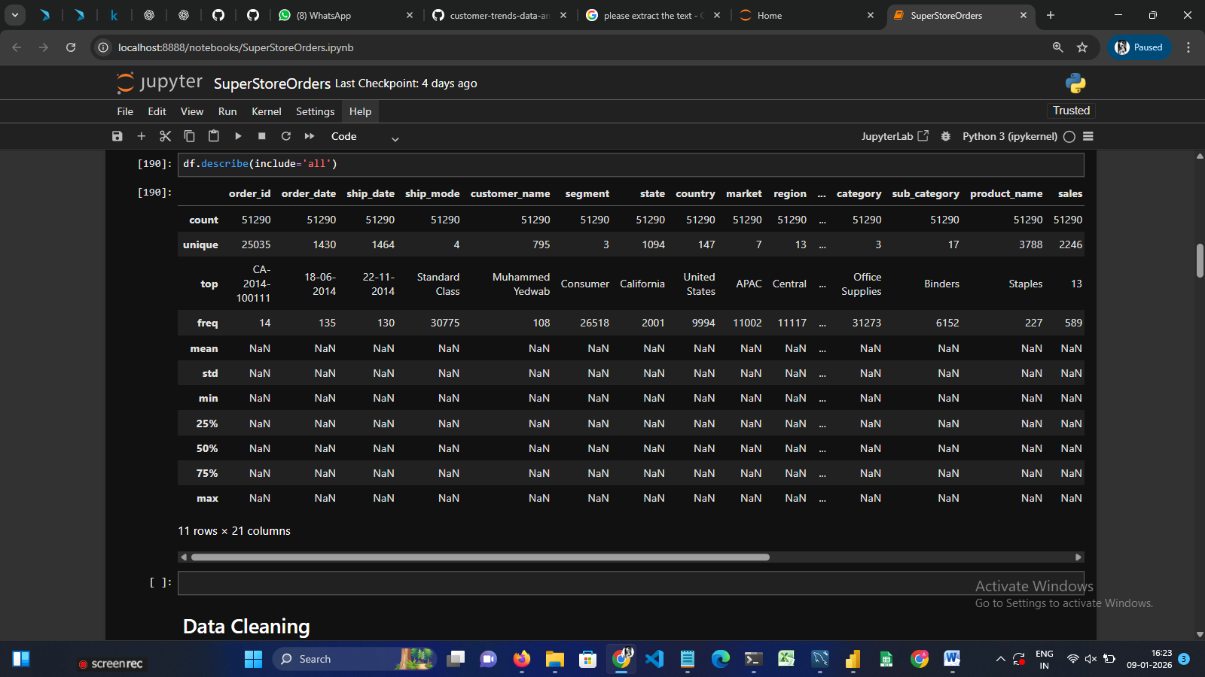

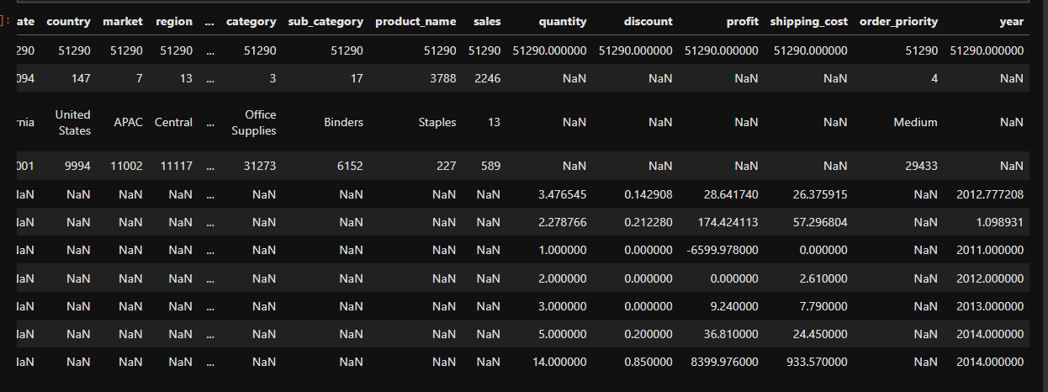

Data Loading
- Imported the dataset using Pandas and inspected its structure using df.info(), and .describe().
Date Formatting
- Converted order_date and ship_date columns to datetime format for time-based analysis.
- Extracted order_year, order_month, and order_day from order_date.
Handling Missing Values
- Checked for missing and null values across all columns.
- Verified that critical fields like sales, profit, and quantity had no missing values.
Feature Engineering
- Created a new column shipping_days by calculating the difference between ship_date and order_date.
- Calculated profit_margin as:
- (profit / sales) * 100
- Ensured division-by-zero cases were handled safely.
Data Type Corrections
- Ensured numeric columns (sales, profit, discount, shipping_cost) were stored in correct numeric formats.
Outlier Review
- Analyzed extreme values in sales and profit to ensure they represent valid business cases and not data errors.
Final Validation
- Verified row count consistency before and after cleaning.
- Confirmed dataset readiness for SQL querying and Power BI visualization.
Database Integration: Connected Python script to MySQL and loaded the cleaned DataFrame into the database for SQL analysis.
4. Data Analysis using SQL (Business Transactions)
We performed structured analysis in MySQL to answer key business questions.
1. Total Sales, Profit & Average Profit Margin - Find total sales, total profit, and average profit margin.
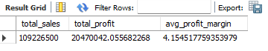
2. Top 5 States by Total Sales - Find total sales, total profit, and average profit margin.
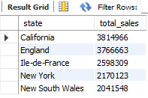
3. Monthly Sales Trend - Show monthly sales trend for each year.
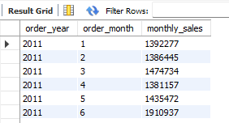
4. Ship Mode Performance - Find average shipping days for each ship mode.
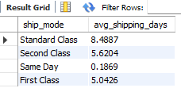
5. Customer Segments Profitability - Which customer segment is most profitable?

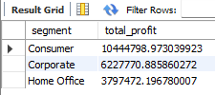
6. Orders with Negative Profit - Find orders where company incurred loss.
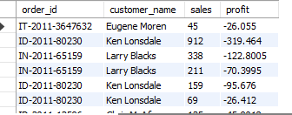
7. Impact of Discount on Profit - Check average profit for different discount levels.
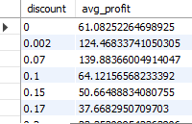
8. High Priority Orders with Fast Shipping - Find high priority orders shipped within 3 days.
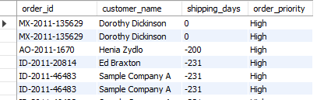
9. Region-wise Sales & Profit Contribution - Show sales and profit by region.
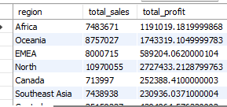
10. Best Month by Profit - Which month generated the highest profit?
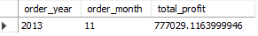
5. Dashboard in Power Bi
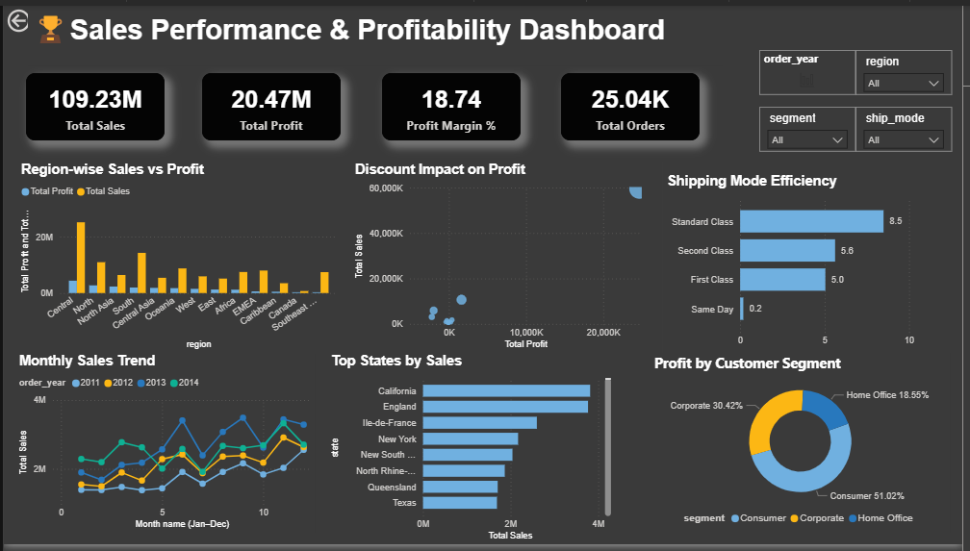

6. Business Recommendations
Optimize Discount Strategy – Reduce high discounts on low-margin products and focus promotions on high-profit categories to protect overall profitability.
Focus on High-Performing Regions – Increase inventory availability and targeted marketing efforts in regions generating the highest sales and profit.
Improve Shipping Efficiency – Promote Standard and Second Class shipping where delivery time and cost are balanced, helping reduce logistics expenses.
Strengthen Customer Segmentation Strategy – Develop personalized offers for Consumer and Corporate segments, which contribute the highest share of profit.
Enhance Monthly Sales Planning – Use seasonal and monthly sales trends to plan campaigns during peak periods and address slow-performing months.
Prioritize Profitable Products – Highlight top-selling and high-margin products in marketing campaigns to maximize revenue impact.
Order Priority Optimization – Evaluate high-priority orders to ensure faster delivery is justified by profit contribution.

